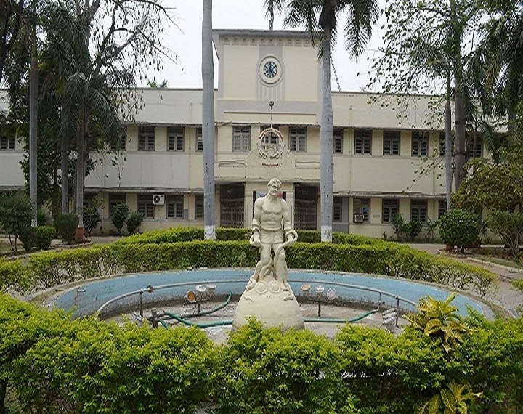

**Call for Papers & Special Sessions**

**ICRISET - 2017**

**International Conference**

On

**RESEARCH AND INNOVATIONS IN**

**SCIENCE, ENGINEERING & TECHNOLOGY**

**17-19 February, 2017**



C:\Users\GTU\Desktop\npiu-logo.jpg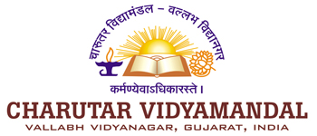 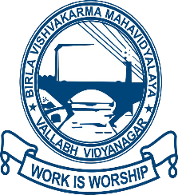 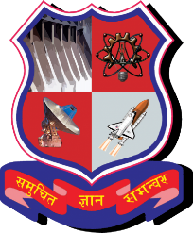

**Organized By:**

**Birla Vishvakarma Mahavidyalaya**

**Engineering College**

**(An Autonomous Institution)**

**Managed by Charutar Vidya Mandal**

**Vallabh Vidyanagar, Anand, Gujarat, India-388120**

**Call for Papers and Conference Themes:**

The Organizers cordially invite abstracts and full length research papers/review papers for oral/poster presentation from all over the world to participate and present in the International Conference.

These engineering subjects are emerging and promising discipline in shaping future research and development activities in both Academia and Industry. The conference aims at providing an opportunity for exchange of ideas and dissemination of knowledge among Academia, Industry, Research Scholars, Scientists and Entrepreneurs for holistic development of the society. Contributions are invited from prospective authors from related areas. All contribution should be of high quality, Original and not published elsewhere or submitted for publication. During the review period, Papers will be reviewed by eminent scholars in the respective areas. All selected and presented papers will be published in International Journals having ISSN and as Conference Proceeding/edited book/abstract book with ISBN in print version and online version and that will be released on the day of conference.

**Tracks of the Conference:**

* [Civil](http://icforest.in/cfp.html#tabs-7) and Structural Engineering
* Electronics and Communication Engineering
* Electrical Engineering
* Computer Engineering & Information Technology
* Mechanical and Production Engineering
* Mathematics and Humanities Science

**Paper Submission:**

Papers should be written in standard American English and should clearly indicate the field of its technical/scientific contribution, and the problems, domains or environments to which it is applicable. Authors are advised to follow ethical norms regarding plagiarism and self-plagiarism thoroughly before submitting and must make sure that their submissions do not substantially overlap work which has been published elsewhere or simultaneously submitted to a journal or another conference with proceedings. Papers that contain any form of plagiarism will be rejected without reviews.

Please send full text paper in a file format doc or docx (Paper Template and Author guidelines are available on conference Website) through Easy chair account link:    [**https://easychair.org/conferences/?conf=icriset2017**](https://easychair.org/conferences/?conf=icriset2017). In case of any trouble through easy chair kindly mail to [icrisetcse@bvmengineering.ac.in](mailto:icrisetcse@bvmengineering.ac.in)

Accepted and Presented paper will be published in reputed journal.

For, paper template please [**Click Here**](http://www.bvmengineering.ac.in/icriset2017/paper%20template.doc)

**Important Dates:**

Full length Paper submission: 15 December, 2016

Acceptance, Revision & Notification due: 5 January, 2017

Camera Ready Paper & Registration: 16 January, 2017

Conference Dates: 17 -19 February, 2017

**Registration Fees (Before 17/01/2017):**

* Indian Delegates (Student/ Research Scholar) : 3000 INR
* Indian Delegates (Academician) : 4000 INR
* Industrial Delegates : 5000 INR
* International Delegates : 250 USD

**Contact Us:**

Organizing Secretaries:  
Dr. J. M. Rathod  
Dr. B. C. Goradiya

Contact number: [7096280489](tel:7096280489)  
E-mail: [icriset2017@bvmengineering.ac.in](mailto:icriset2017@bvmengineering.ac.in)

**Address:**Birla Vishvakarma Mahavidyalaya  
Engineering College, Mota Bazaar,  
Vallabh Vidya Nagar,  
Opp Shastri Maidan, Anand,  
Gujarat 388120

INDIA